**Referenced Supporting Information Figure Captions**

Figure S1 A schematic representation of widths to height ratios (not to scale) for the (a) 0.25º and (b) 0.5º equilateral grid cells at different depths.

Figure S2 Grid nodes around a point (P) within a block with the eight vertices denoted by N1, N2, N3, N4, N5, N6, N7, and N8.

Figure S3 Result of checkerboard resolution test for East-West Vertical Cross-sections (EWVC) for (a) 0.25º × 0.25º and (b) 0.50º × 0.50º grid spacings. The depth axis is about 5 times exaggerated. **MS** (Malacca Strait), **PM** (Peninsular Malaysia), **PME** (East coast of Peninsular Malaysia), **SCS** (South China Sea), **SS** (Singapore Strait) and **Su** (Sumatra). The forward slash between the character symbols denotes their boundary. Letters in purple are station codes.

Figure S4 Result of checkerboard resolution test of North-South vertical cross-sections (NSVC) for (a) 0.25º × 0.25º and (b) 0.50º × 0.50º grid spacings. The depth axis is about 5 times exaggerated. **MS** (Malacca Strait), **PM** (Peninsular Malaysia), **PME** (East coast of Peninsular Malaysia), **SCS** (South China Sea), **SS** (Singapore Strait), **Su** (Sumatra) and **TH** (Thailand). The forward slash between the character symbols denotes their boundary. Letters in purple are station codes.

Figure S5 Inversion result of using stations and Pn arrival published by Lu *et al.* (2022) for Hainan Island in China. (a) Histogram of travel-time residuals with an interval of 0.5 seconds. (b) Results of checkerboard resolution at a depth of 50 km. (c) The tomographic model at a depth of 50 km.

Figure S6 Inversion result of Toyokuni *et al.* (2022) extracted for the study region at depths of (a) 32.5 km and (b) 50.0 km.



Figure S1 A schematic representation of widths to height ratios (not to scale) for the (a) 0.25º and (b) 0.5º equilateral grid cells at different depths.

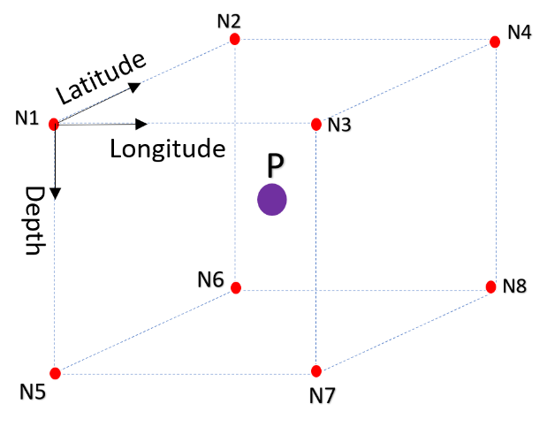

(a)

Figure S2 Grid nodes around a point (P) within a block with the eight vertices denoted by N1, N2, N3, N4, N5, N6, N7, and N8.



(a)



(b)

Figure S3 East-West vertical cross-sections (EWVC) through the checkerboard resolution for (a) 0.25º × 0.25º and (b) 0.50º × 0.50º grid spacings. The depth axis is about 5 times exaggerated. **MS** (Malacca Strait), **PM** (Peninsular Malaysia), **PME** (East coast of Peninsular Malaysia), **SCS** (South China Sea), **SS** (Singapore Strait) and **Su** (Sumatra). The forward slash between the character symbols denotes their boundary. Letters in purple are station codes.



(a)

(b)



Figure S4 East-West vertical cross-sections (EWVC) through the checkerboard resolution for (a) 0.25º × 0.25º and (b) 0.50º × 0.50º grid spacings. The depth axis is about 5 times exaggerated. **MS** (Malacca Strait), **PM** (Peninsular Malaysia), **PME** (East coast of Peninsular Malaysia), **SCS** (South China Sea), **SS** (Singapore Strait), **Su** (Sumatra) and **TH** (Thailand). The forward slash between the character symbols denotes their boundary. Letters in purple are station codes.



Figure S5 Inversion result of using stations and Pn arrival published by Lu *et al.* (2022) for Hainan Island in China. (a) Histogram of traveltime residuals with an interval of 0.5 seconds. (b) Results of checkerboard resolution at a depth of 50 km. (c) The tomographic model at a depth of 50 km.



Figure S6 Inversion result of Toyokuni *et al.* (2022) extracted for the study region at depths of (a) 32.5 km and (b) 50.0 km.